# Create a new component which has news title (<h2>), news detail (<p>), published date, and

source. Create this component using Sling Model.

In AEM, components can use **Sling Models** to bind backend data to frontend views. Here, we create a simple **News Item component** with the following fields:

* + Title
  + Detail
  + Published Date
  + Source

These fields are defined in the dialog and accessed using a Sling Model in the HTL (HTML Template Language).

### Sling Model: NewsItemModel.java

package com.example.core.models;

import org.apache.sling.api.resource.Resource;

import org.apache.sling.models.annotations.DefaultInjectionStrategy; import org.apache.sling.models.annotations.Model;

import javax.inject.Inject;

@Model(adaptables = Resource.class, defaultInjectionStrategy = DefaultInjectionStrategy.OPTIONAL)

public class NewsItemModel {

@Inject

private String title;

@Inject

private String detail;

@Inject

private String publishedDate;

@Inject

private String source;

public String getTitle() { return title;

}

public String getDetail() { return detail;

}

public String getPublishedDate() { return publishedDate;

}

public String getSource() { return source;

}

}

### HTL File: news-item.html

<data-sly-use.news="com.example.core.models.NewsItemModel" />

<div class="cop-news-component">

<h2 class="news-title">${news.title}</h2>

<p class="news-detail">${news.detail}</p>

<p class="news-date">${news.publishedDate}</p>

<p class="news-source">Source: ${news.source}</p>

</div>

### What’s Happening?

* + The Sling Model fetches the fields from the component dialog.
  + HTL template uses this model and renders the data in proper HTML tags.
  + CSS class cop-news-component helps with styling.

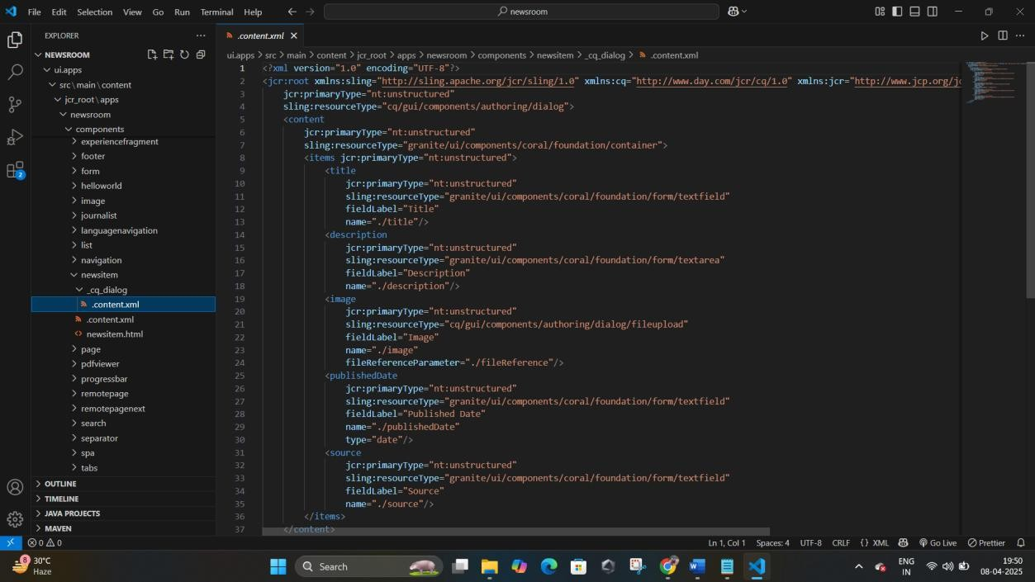

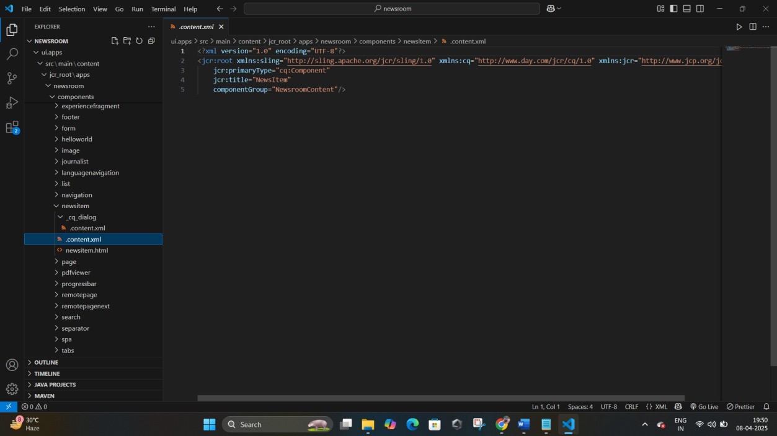

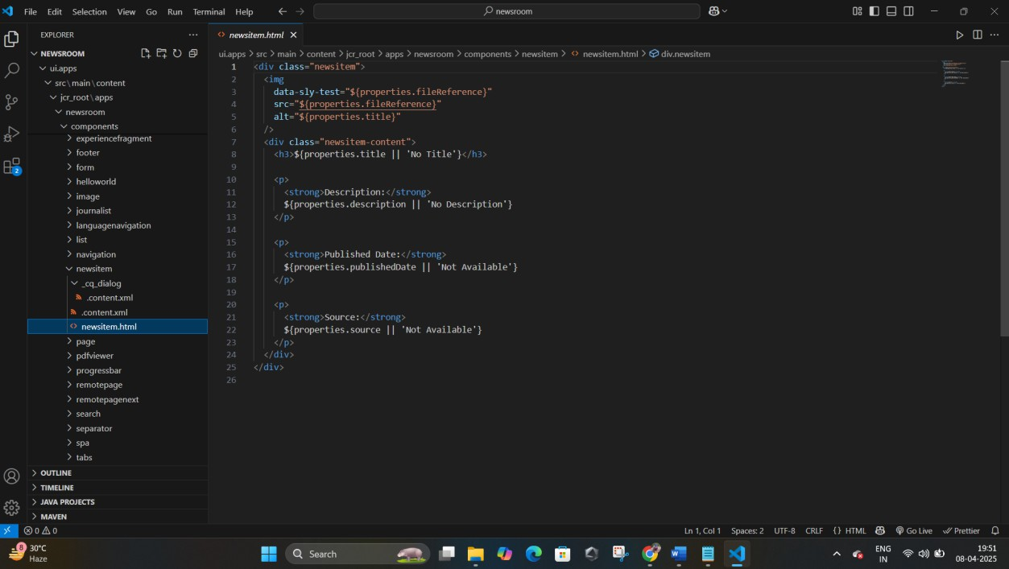

# Create multifield component (multiple news) using Sling Model. Fields: title of news and source of

news

### Explanation:

A **multifield component** allows authors to input multiple sets of similar data (e.g., multiple news items). Here, each news item includes:

* + Title
  + Source We use:
  + A Coral UI Multifield dialog
  + A Sling Model to map a list of items
  + HTL to loop over and render each item

### cq:dialog XML

<newsItems

jcr:primaryType="nt:unstructured"

sling:resourceType="granite/ui/components/coral/foundation/form/multifield" fieldLabel="News Items"

name="./newsItems"

composite="{Boolean}true">

<field

jcr:primaryType="nt:unstructured"

sling:resourceType="granite/ui/components/coral/foundation/form/fieldset">

<layout

jcr:primaryType="nt:unstructured"

sling:resourceType="granite/ui/components/coral/foundation/layouts/fixedcolumns"/>

<items jcr:primaryType="nt:unstructured">

<title

jcr:primaryType="nt:unstructured"

sling:resourceType="granite/ui/components/coral/foundation/form/textfield" fieldLabel="Title"

name="./title"/>

<source

jcr:primaryType="nt:unstructured"

sling:resourceType="granite/ui/components/coral/foundation/form/textfield" fieldLabel="Source"

name="./source"/>

</items>

</field>

</newsItems>

### NewsMultifieldModel.java

package com.example.core.models;

import org.apache.sling.api.resource.Resource;

import org.apache.sling.models.annotations.DefaultInjectionStrategy; import org.apache.sling.models.annotations.Model;

import javax.inject.Inject; import java.util.List;

@Model(adaptables = Resource.class, defaultInjectionStrategy = DefaultInjectionStrategy.OPTIONAL)

public class NewsMultifieldModel {

@Inject

private List<NewsItem> newsItems;

public List<NewsItem> getNewsItems() { return newsItems;

}

@Model(adaptables = Resource.class) public static class NewsItem {

@Inject

private String title;

@Inject

private String source;

public String getTitle() { return title; }

public String getSource() { return source; }

}

}

### news-multifield.html

<data-sly-use.newsList="com.example.core.models.NewsMultifieldModel" />

<ul class="cop-news-component">

<data-sly-list.newsItem="${newsList.newsItems}">

<li>

<h2>${newsItem.title}</h2>

<p>Source: ${newsItem.source}</p>

</li>

</data-sly-list>

</ul>

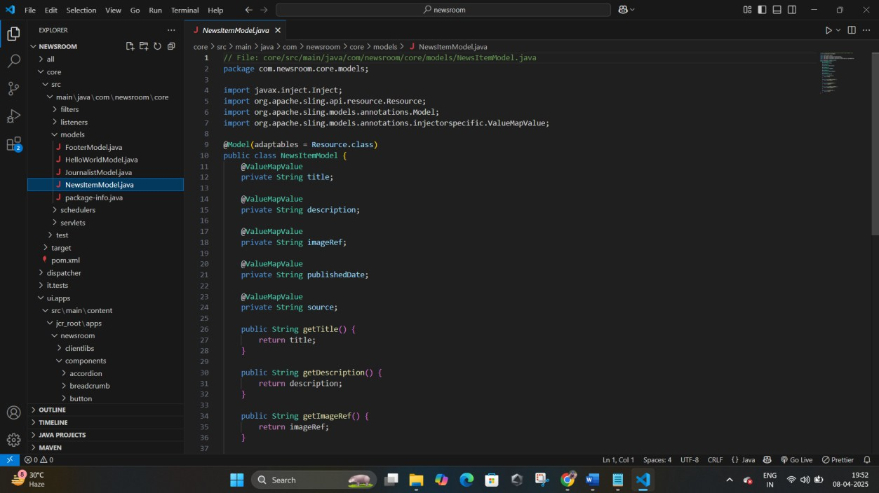

# Create clientlibs for news component

### Explanation:

clientlibs in AEM allow us to add custom CSS or JS to components. We’ll create a clientlib to style the news component.

/apps/news/clientlibs/newscomponent

* css.txt
* news.css

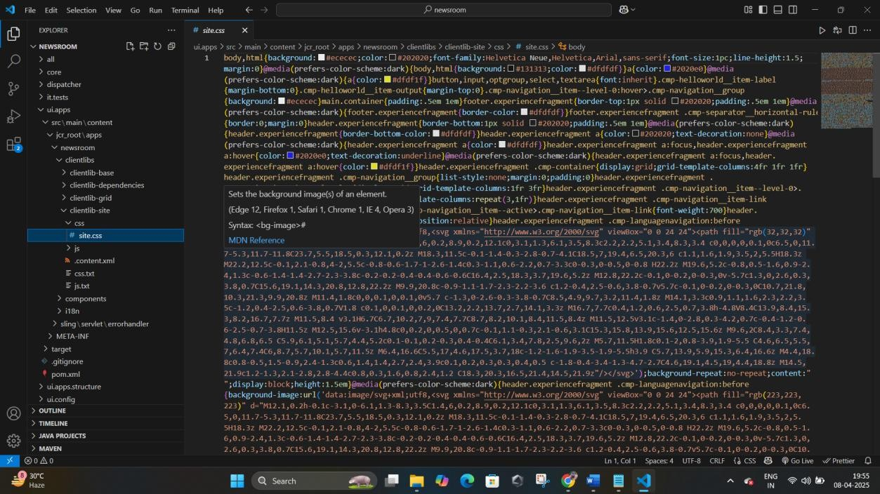

# Apply color styles: Green for heading, Yellow for detail <p>, Black for date

Already handled in news.css:

.news-title { color: green; }

.news-detail { color: yellow; }

.news-date { color: black; }

# Add Component Style: Add custom style class cop- news-component

Already used in both HTL files:

<div class="cop-news-component">

# Create base page component and add metadata

(og:title, og:description, og:image). Link metadata file in base page

## Explanation:

We want to support Open Graph tags (used by Facebook, LinkedIn, etc.) for better sharing. We'll use a head-meta.html file and include it in our basepage.html.

### basepage.html

<head>

<sly data-sly-include="head-meta.html" />

</head>

head-meta.html

<meta property="og:title" content="${currentPage.properties['og:title']}" />

<meta property="og:description" content="${currentPage.properties['og:description']}" />

<meta property="og:image" content="${currentPage.properties['og:image']}" />

# Create custom page properties tab: Global Properties with fields og:title, og:description, og:image

## Dialog XML:

Add this under /apps/your- project/components/page/cq:dialog/content/items/tabs/items/basic/items

<globalProperties

jcr:primaryType="nt:unstructured"

sling:resourceType="granite/ui/components/coral/foundation/container"

jcr:title="Global Properties">

<items jcr:primaryType="nt:unstructured">

<ogTitle

jcr:primaryType="nt:unstructured"

sling:resourceType="granite/ui/components/coral/foundation/form/textfield" fieldLabel="OG Title"

name="./og:title"/>

<ogDescription

jcr:primaryType="nt:unstructured"

sling:resourceType="granite/ui/components/coral/foundation/form/textarea" fieldLabel="OG Description"

name="./og:description"/>

<ogImage

jcr:primaryType="nt:unstructured"

sling:resourceType="granite/ui/components/coral/foundation/form/pathfield" fieldLabel="OG Image"

name="./og:image"/>

</items>

</globalProperties>

# What is extraClientlibs? Add it to the multifield component

## Explanation:

extraClientlibs is used to load additional client-side resources (JS/CSS) **in the author dialog**, not the page.

### How to Add:

In your cq:dialog root node:

extraClientlibs = ["newsroom.dialog"]

### Create ClientLib:

Path: /apps/newsroom/clientlibs/dialog categories = newsroom.dialog

Then add any JS/CSS needed to support dialog functionality.

